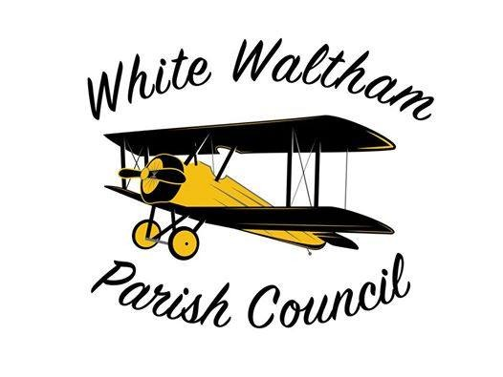

**5-Year Strategy  
2024–2028**

**Revised September 2025**

# Introduction

This strategy sets out White Waltham Parish Council’s vision and priorities for the period 2024–2028. It reflects our commitment to supporting local residents, protecting our environment, sustaining community facilities, and preparing for future challenges. The document has been developed following councillor discussions, parish feedback and consideration of our Neighbourhood Plan.

Our priorities are grouped into five main themes:

1. Housing and Development
2. Sustainability and Environment
3. Community and Facilities
4. Transport and Infrastructure
5. Business and Employment

# Housing and Development

## Our Commitments:

* Assess all planning applications carefully and consistently.
* Support affordable housing for local residents where appropriate.
* Engage early with developers to shape proposals in line with parish priorities.

## Key Actions 2024–2028:

* Complete councillor training on planning law and policy.
* Carry out a Housing Needs Assessment.
* Identify and explore opportunities to create affordable housing for local residents.
* Share council decisions with RBWM in a timely and transparent way.

# Sustainability and Environment

## Our Commitments:

* Move towards sustainable energy use and waste reduction across council activities.
* Maintain and improve parish green spaces for the benefit of people and nature.
* Encourage community involvement in biodiversity and sustainability projects.

## Key Actions 2024–2028:

* Develop an environmental plan for council buildings.
* Reduce paper use and move towards a paper-free office.
* Introduce energy efficiency measures, including renewable energy options.
* Update management plans for all council-owned land.
* Establish a biodiversity action plan and create “Friends of…” groups where possible.

# Community and Facilities

## Our Commitments:

* Protect local shops, pubs and essential services.
* Support families, young people and vulnerable groups.
* Ensure parish recreation sites are safe, well-maintained and accessible.
* Build strong links with police, wardens and community groups.
* Safeguard local assets of community value.

## Key Actions 2024–2028:

* Explore support for toddler groups and youth provision.
* Promote wider use of tennis courts, allotments and footpaths.
* Meet regularly with police representatives and encourage resident reporting of issues.
* Maintain a register of community assets and ensure they are considered in planning.

# Transport and Infrastructure

## Our Commitments:

* Address traffic hot spots in partnership with residents and stakeholders.
* Promote sustainable transport options, including bus services, walking and cycling.
* Support the transition to electric vehicles.

## Key Actions 2024–2028:

* Identify traffic problem areas and develop local action plans.
* Explore Community Speedwatch and speed warning signs.
* Engage with bus providers to improve services.
* Work with RBWM on a cycle path between Woodlands Park and White Waltham.
* Assess EV charging provision in council-owned car parks and new developments.

# Business and Employment

## Our Commitments:

* Protect existing business sites from inappropriate change of use.
* Promote high-speed broadband and modern infrastructure.
* Consider parking and access for local businesses.

## Key Actions 2024–2028:

* Identify and safeguard key employment sites.
* Support delivery of full-fibre broadband across the parish.
* Encourage policies that balance residential growth with business needs.

# Implementation and Review

This strategy will be monitored regularly by White Waltham Parish Council and updated as required. Progress against actions will be reported at annual parish meetings and through council communications.

**White Waltham Parish Council**

Woodlands Park Village Centre  
Manifold Way  
Woodlands Park  
Maidenhead  
Contact: clerk@wwpc.co.uk